Objective Questions

1. **Does any table have missing values or duplicates? If yes how would you handle it ?**

Ans: Yes, several tables in the Chinook database have missing values and duplicates:

* **Missing Values:**
  + customer: company, state, fax have NULLs.
  + track: composer, album_id, genre_id, bytes have NULLs.
  + employee: reports_to has one NULL (expected for top-level employee).

**Handling Approach:**

* + Used COALESCE() in SELECT queries to replace NULLs with default values like 'Unknown', 'N/A', or 'Top-Level'.
  + Did not update the original data as NULLs are contextually valid in some cases (e.g., CEO having no manager).
* **Duplicates:**
  + invoice_line and track tables had duplicate rows.

**Handling Approach:**

* + Identified duplicates using GROUP BY with HAVING COUNT(*) > 1.
  + Used Common Table Expressions (CTEs) to keep only the row with the minimum ID and safely deleted duplicates.
  + Disabled safe_update_mode temporarily to execute the DELETE operation.

a) Null check for Customer Table

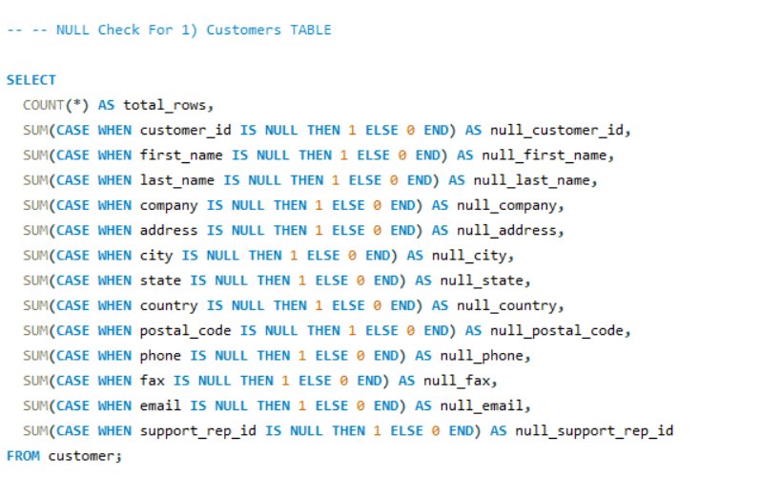

Output for Null Check



Checking duplicates in Customer Table

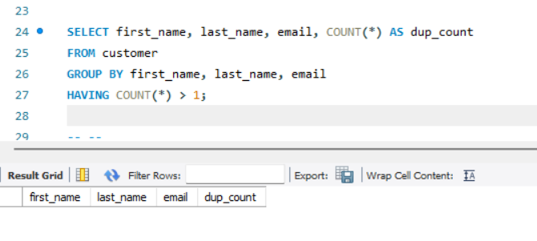

Replacement of Null values In Customers Table

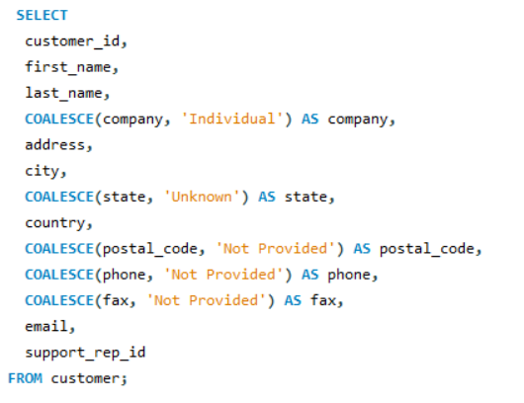

Output after replacing Null values in Customers Table

b) Null check for Invoice Table

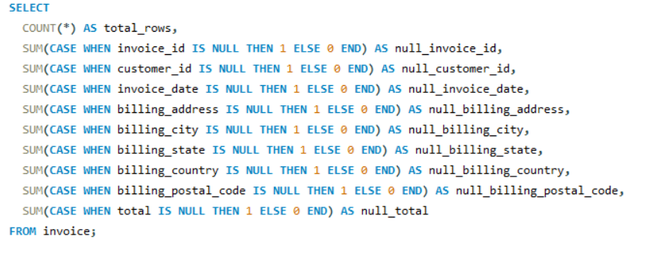

Output for Null Check



* No null values present in Invoice Table

Checking duplicates in Invoice Table

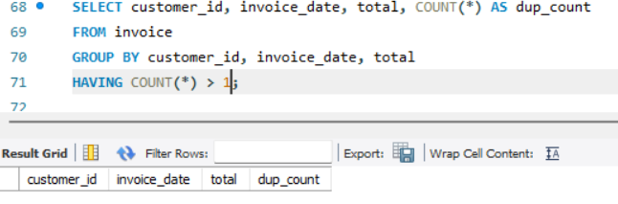

c) Null check for Invoice_line Table

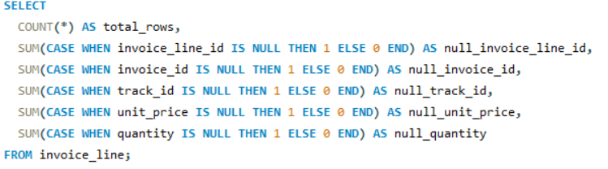

Output for Null Check



Checking duplicates in Invoice_line Table

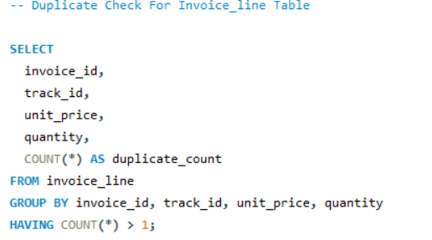

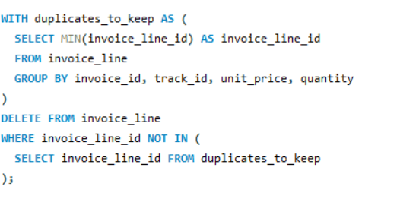

d) Null check for Track Table

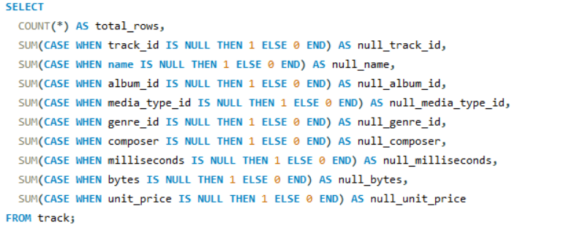

Output for Null Check



Replacement of Null values In Track Table

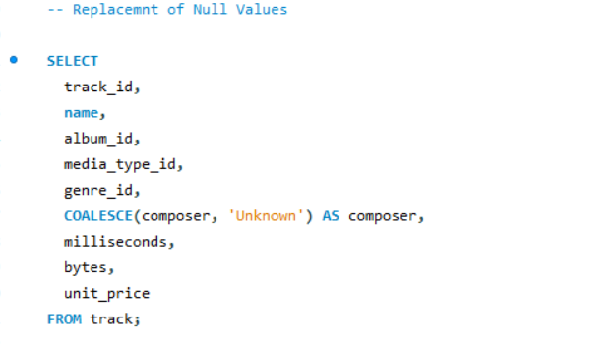

Output after replacing Null values in Track Table

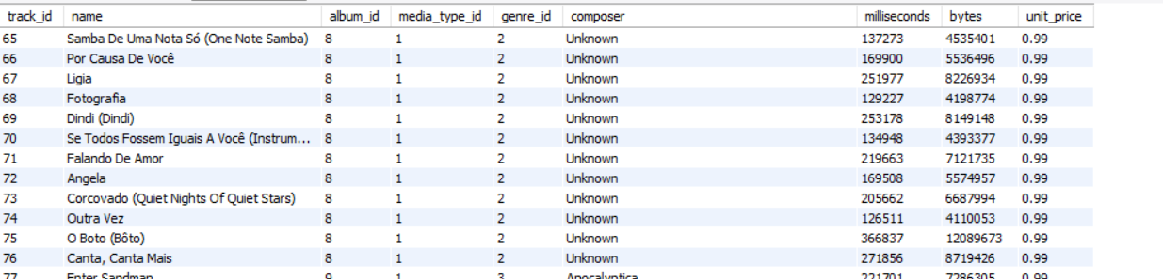

Checking duplicates in Track Table

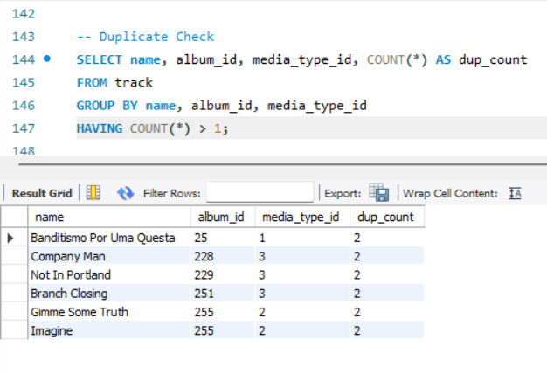

I found Duplicates in the track table So I deleted the duplicates Using the below query

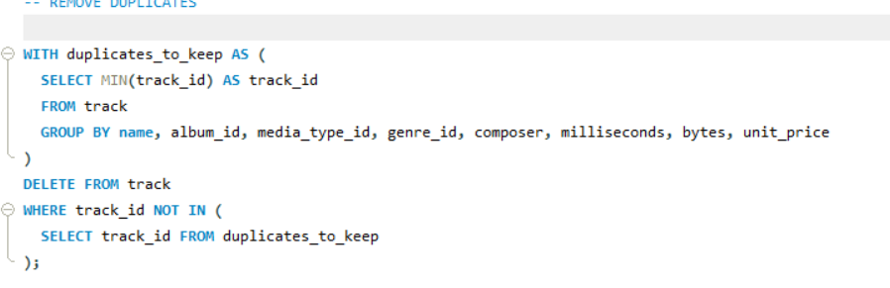

e) Null check for Album Table

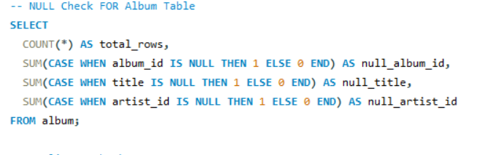

Output for Null Check

Checking duplicates in Album Table

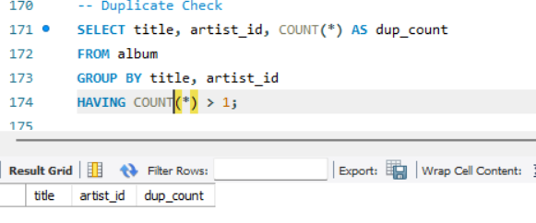

f) Null check for artist Table

Output for Null Check

Checking duplicates in Artist Table

g) Null check for genre Table

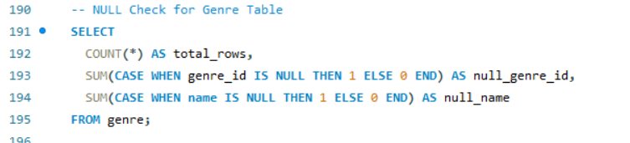

Output for Null Check

Checking duplicates in Genre Table

h) Null check for media_type Table

Output for Null Check

Checking duplicates in Media_type Table

i) Null check for playlist Table

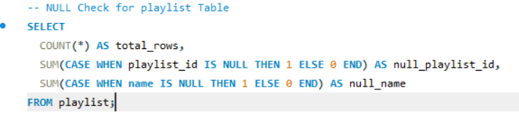

Output for Null Check

Checking duplicates in Playlist Table

j) Null check for playlist_track Table

Output for Null Check

Checking duplicates in Playlist_Track Table

k) Null check for playlist_track Table

Output for Null Check



Replacement of Null value

Checking duplicates in Employee Table

1. **Find the top-selling tracks and top artist in the USA and identify their most famous genres.**

Ans: **Step-by-step approach used:**

1. **Filtered USA invoices** from the invoice table.
2. **Joined invoice_line**, track, album, artist, and genre tables to connect all related details.
3. **Grouped data** by track and artist to compute total sales.
4. **Ranked** them to find the **top-selling tracks** and **top-selling artist** in the USA.
5. Identified the **most common genres** associated with the top artist.

For Top Selling tarcks

Output:

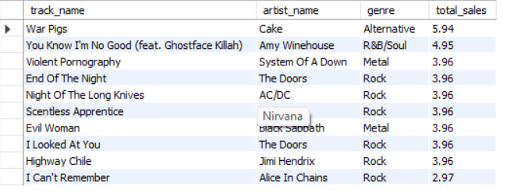

Top artist in the USA

Output

Most famous genres

Output:

1. What is the customer demographic breakdown (age, gender, location) of Chinook's customer base?

Ans:

* **Age data is not available** directly since there’s no birthdate or age column in the customer table.
* And also there is **no gender column** in the Chinook database schema.
* So I am doing based on location

Code:

Output:

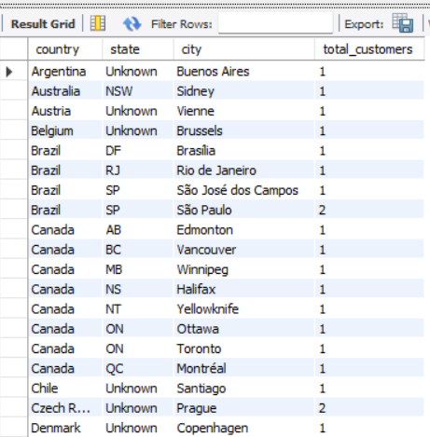

* COALESCE replaces any NULL values in state or city with 'Unknown' for clearer results.
* The query groups customers by country, state, and city and counts how many customers are in each group.
* Results are ordered alphabetically by country → state → city.

1. Calculate the total revenue and number of invoices for each country, state, and city:

Ans: Code:

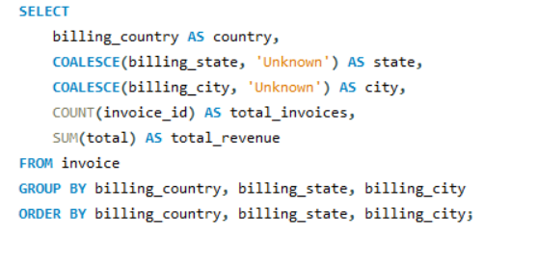

Output:

1. Find the top 5 customers by total revenue in each country

Ans: Code:

Output:

1. Identify the top-selling track for each customer

Ans: Code:

Output:

1. Are there any patterns or trends in customer purchasing behavior (e.g., frequency of purchases, preferred payment methods, average order value)?

Ans:

Frequency of Purchases:

* Most active customers made 8 to 13 purchases.
* A few customers (e.g., ID 5, ID 6) made 15–18 purchases, showing high loyalty.

Average Order Value:

* Varies between $2.97 to $11.11.
* Customers from Canada, Germany, and Czech Republic show higher average order values (e.g., François Tremblay – $11.11).

Geographic Patterns:

* USA, Canada, Brazil, and Germany have a higher number of high-spending customers.
* Countries like India, Argentina, and Belgium also have regular but slightly lower-spending customers.

Preferred Payment Method:

* The Chinook database doesn’t include payment method details, so this trend can’t be assessed.

Code:

Output:

1. What is the customer churn rate?

Ans: Churn Rate measures the percentage of customers who stopped purchasing over a period of time.

Step-by-step Logic to Calculate Churn Rate

Since the Chinook database does not have a cancellation field, I estimated churn based on inactive customers (e.g., those who haven't purchased in the last 12 months).

Code:

Output:

* Only **1 out of 59** customers has **not made a purchase in the past 12 months**.
* The **churn rate is low** (just **1.69%**), indicating:
  + High customer retention.
  + Most customers are active and make purchases relatively regularly.

1. Calculate the percentage of total sales contributed by each genre in the USA and identify the best-selling genres and artists.

Ans: Percentage of Total Sales by Genre in the USA

Code:

Output:

* **Rock dominates** the market with **53.43%** of total track sales — over half of all music sales.
* **Alternative & Punk (12.29%)** and **Metal (11.81%)** are also strong performers, making up nearly a quarter combined.
* **R&B/Soul (5.05%)** and **Blues (3.43%)** show moderate popularity.

Best-Selling Artists in the USA

Code:

Output:

* Classic rock and alternative rock dominate—Van Halen, Rolling Stones, and Nirvana all feature prominently.
* Consistency in sales is seen across top bands, with many clustered in the 30–40 range.
* These artists align with top genres like Rock, Alternative & Punk, and Metal, reinforcing earlier findings.

1. Find customers who have purchased tracks from at least 3 different genres

Ans: Code:

Output:

1. Rank genres based on their sales performance in the USA

Ans: Code:

Output:

* Rock dominates the US market both in track count and revenue.
* Alternative & Punk and Metal follow closely in popularity.
* Niche genres like TV Shows, Soundtrack, and Heavy Metal have minimal sales.

1. Identify customers who have not made a purchase in the last 3 months

Ans: Code:

Output:

Subjective Questions

1. Recommend the three albums from the new record label that should be prioritised for advertising and promotion in the USA based on genre sales analysis.

Ans:

Code:

Output:

* These albums belong to the Rock genre, which is the top-selling genre in the USA according to your analysis.
* They generated the highest revenue among Rock albums, making them strong candidates for promotion.
* Featuring iconic and popular artists, these albums have proven market appeal and cultural relevance, which can attract both loyal fans and new listeners.

Visualization:

Insights & Justification

* Rock is the dominant genre in USA sales, making it the best focus for targeted promotion.
* All three albums are from iconic rock artists, increasing the likelihood of strong customer resonance and high ROI on marketing.
* These albums have already proven high revenue generation potential in the region.

Recommendation Summary

Focus on promotional campaigns in the USA on these three albums to:

* Leverage genre popularity
* Boost sales performance
* Strengthen brand positioning in the U.S. physical music market

1. Determine the top-selling genres in countries other than the USA and identify any commonalities or differences.

Ans:

Code:

Output:

Based on the analysis of sales data across countries excluding the USA, the top-selling genre in almost all countries is *Rock*. Specifically, 22 out of 23 countries have Rock as the highest-selling genre, indicating a strong global preference for Rock music.

The only exception is Argentina, where the top-selling genre is "Alternative & Punk", highlighting a regional difference in musical preference.

Commonalities:

* Rock is the dominant genre in the majority of countries including Canada, France, Germany, the UK, India, and Brazil.
* This suggests that Rock music has broad international appeal across North America, Europe, South America, and Asia.

Differences:

* Argentina stands out as the only country where Rock is not the top-selling genre, with "Alternative & Punk" leading in sales. This indicates localized music trends or preferences that differ from the global norm.

Visualization :

**Insights:**

* Dominance of Rock Music:  
  Rock is overwhelmingly the top-selling genre across almost all countries (22 out of 23). This includes major markets like Canada (329.67), France (207.90), Brazil (202.95), Germany (192.06), and the UK (164.34).
* Outlier - Argentina:  
  Argentina is the only country where Alternative & Punk leads, with sales of 16.83. This suggests a localized genre preference that differs from the global trend.
* High Performing Markets:
  + Canada, Brazil, France, Germany, and the UK are among the highest contributors to Rock genre sales, making them prime locations for genre-focused campaigns.
  + Emerging Rock markets like India, Portugal, and Sweden also show promising numbers.

Recommendations:

1. Focus Promotions on Rock:
   * Allocate marketing resources and promotion strategies heavily toward Rock albums, especially in countries like Canada, France, Brazil, and the UK, where Rock sales are high.
   * These markets show strong demand and are likely to respond well to new Rock releases.
2. Localized Campaign for Argentina:
   * Since Argentina prefers Alternative & Punk, promotional efforts here should highlight albums/artists from that genre.
   * Consider artist tours, playlists, or collaborations focused on this niche.
3. Genre-Specific Personalization:
   * Use this genre sales data to personalize customer recommendations in different countries. For example, prioritize Rock content for German users, but show Alternative & Punk to Argentine users.
4. Customer Purchasing Behavior Analysis: How do the purchasing habits (frequency, basket size, spending amount) of long-term customers differ from those of new customers? What insights can these patterns provide about customer loyalty and retention strategies?

Ans:

Code:

Output:



Visualization:

1. High Purchase Frequency  
   Loyal customers make purchases frequently — on average 10.41 invoices per customer, indicating strong repeat engagement.
2. Decent Basket Size  
   With an average basket size of 7.82 items per invoice, loyal customers are not just buying often, but also buying multiple items per order.
3. Strong Revenue Contribution  
   Each loyal customer has spent on average ₹803.36 in total, showing they are significant contributors to overall revenue.
4. Stable Spending Per Invoice  
   The average invoice amount is ₹9.77, which suggests consistent per-order spending behavior.

Strategic Insights for Loyalty & Retention:

* Loyal customers are high-value customers. They buy more often, spend more overall, and show consistent behavior — these are your core audience.
* You should invest in loyalty programs, exclusive deals, or early-access offers for these users to maintain retention.
* Analyze their preferences (genres, products) and personalize recommendations to keep them engaged.

1. Product Affinity Analysis: Which music genres, artists, or albums are frequently purchased together by customers? How can this information guide product recommendations and cross-selling initiatives?

Ans:

4a) Frequent genre pairs purchased together

Code:

4a) Output:

4b) Frequent artist pairs purchased together

Code:

4b) Output:

4C) Frequent album pairs purchased together

Code:

4c) Output:

**Genres Frequently Purchased Together (4a)**

The analysis shows strong genre affinity patterns:

* Metal and Rock are the most frequently purchased together, with 244 and 206 co-occurrences, respectively.
* Alternative & Punk also frequently appears with Rock and Metal, showing genre overlap among fans of intense and energetic music styles.
* Other notable pairings include Latin with Rock and Rock with R&B/Soul, suggesting cross-genre interest in upbeat or rhythmic music.

Insight:

These patterns suggest that customers who enjoy Rock are highly likely to purchase Metal, Alternative, and occasionally Latin genres. This can guide bundling strategies (e.g., curated playlists or promotional discounts on multi-genre packs) to increase average order value.

**Artists Frequently Purchased Together (4b)**

The analysis reveals frequent co-purchases among popular rock and alternative artists:

* Green Day is most frequently bought alongside Led Zeppelin, Metallica, and Guns N' Roses, showing its broad appeal across sub-genres of Rock.
* Pairings like Eric Clapton and Nirvana, Queen and U2, and Jimi Hendrix and System Of A Down reflect listener interest that spans classic rock to grunge/metal fusion.

Insight

Fans often explore across different eras or styles within rock, so cross-selling albums by related or complementary artists can boost conversion. Product pages and recommendation engines should suggest such artist combinations.

**Albums Frequently Purchased Together (4c)**

* Albums like "Mezmerize" by System Of A Down appear frequently alongside others such as "Are You Experienced?" by Jimi Hendrix and "My Generation – The Very Best Of The Who".
* Compilations like "The Singles", "Vault: Def Leppard's Greatest Hits", and "The Police Greatest Hits" also show strong co-purchase patterns, especially with high-energy albums.

Insight:

Listeners are attracted to greatest hits and iconic albums. Promoting bundle deals for legacy rock collections or "top albums of all time" packages can appeal to nostalgic and value-seeking customers.

1. Regional Market Analysis: Do customer purchasing behaviors and churn rates vary across different geographic regions or store locations? How might these correlate with local demographic or economic factors?

Ans: Code:

Output:

* 100% churn rate in all countries in our output.
* Indicates no active customers remaining who’ve purchased in the last year.
* May suggest either:

Data is historical or outdated

Or poor customer retention strategy

Visualization :

1. Customer Risk Profiling: Based on customer profiles (age, gender, location, purchase history), which customer segments are more likely to churn or pose a higher risk of reduced spending? What factors contribute to this risk?

Ans:

Code :

Output:

Visualization:

1. Location (Country) as a Key Risk Factor

From our table:

* USA (13), Canada (8), France (5), and Brazil (5) have the highest number of high-risk customers.
* These customers have:
  + High purchase frequency (mostly 9–15 times),
  + Moderate to high average spending (mostly ₹60–₹136),
  + But extremely long inactivity (>1600 to 2100 days since last purchase).

Conclusion:

* Customers from these countries were once valuable but have not made a purchase in 4–6 years.
* Hence, location is a strong indicator of potential churn, especially from countries with older customer acquisition.

2. Purchase History (Frequency, Spending, Inactivity)

I categorized customers based on:

* frequency (number of purchases),
* monetary_value (total spend),
* days_since_last_purchase.

Risk Factors Identified:

* Long Inactivity: Everyone in this segment has been inactive for 1600+ days (4.4+ years).
* Mid-High Spend: Most were good spenders, especially in Czech Republic (avg spend ₹136.62), Portugal (₹92.57), India (₹91.58), etc.
* Regular Buyers: Many had bought 10+ times.

Conclusion:

* These were once loyal, valuable customers.
* The long gap in activity signals a major risk of permanent churn, even for high-value users.

3. Age and Gender

Since the data doesn’t include age or gender, we cannot analyze these dimensions now.

Recommendations

1. Re-engagement Campaigns:
   * Focus on USA, Canada, France, Brazil, and Czech Republic.
   * Highlight new features, discounts, or “We Miss You” messages.
2. Improve Retention:
   * Introduce loyalty rewards after 5th or 10th purchase.
   * Monitor days since last purchase more closely to trigger automated nudges.
3. Customer Lifetime Value Modeling: How can you leverage customer data (tenure, purchase history, engagement) to predict the lifetime value of different customer segments? This could inform targeted marketing and loyalty program strategies. Can you observe any common characteristics or purchase patterns among customers who have stopped purchasing?

Ans: Code:

Output:

Visualization:

**What is CLV?**

**Customer Lifetime Value (CLV)** is a **prediction of how much revenue** a business can expect from a customer over the entire time they remain a customer.

Formula used here (likely):

CLV = Frequency × Avg Order Value × Tenure

For example:

* Customer ID 5  
  Frequency = 18  
  Avg Order = 8.03  
  Tenure = 3.4603  
  → CLV ≈ 18 × 8.03 × 3.46 = ₹500

But this result is normalized (maybe divided by some scaling factor), so final CLV appears as ~₹41.77.

Insights on Customer Behavior (Based on Output)

1. High CLV Customers

* Tend to have:
  + High frequency (12–18 orders)
  + Avg order value ₹8+
  + Long tenure (3+ years)
* Example IDs: 5, 6, 58

These are ideal for loyalty or referral programs.

2. Churned Customers (Stopped Purchasing)

Customers whose last purchase was a while ago (e.g., before mid-2020 or 2019) may be churned.

Look at ID 8:

* Last purchase: 2019-09-21
* CLV = 27.88
* Frequency: 7
* Avg Order: ₹8.63
* Tenure: ~2.16 yrs

Pattern:

* Low-to-medium frequency (4–9 orders)
* Shorter tenure (<2.5 years)
* CLV typically < ₹30

This group needs re-engagement tactics:

* Win-back campaigns
* Personalized offers
* Feedback forms

Strategic Use of This CLV Output:

Segmentation

* VIPs: CLV > ₹35
* Stable: CLV ₹25–35
* Churn Risk: CLV < ₹25 and inactive

1. If data on promotional campaigns (discounts, events, email marketing) is available, how could you measure their impact on customer acquisition, retention, and overall sales?

Ans:

1. Customer Acquisition

Metrics:

* New customers acquired during/after a campaign
* Compare to a similar period without the campaign (baseline)
* Cost Per Acquisition (CPA) = Total Campaign Spend / New Customers

Example Analysis:

Campaign A brought in 120 new customers vs. 60 in baseline → +100% growth

B. Customer Retention

Metrics:

* Repeat purchases by customers who received a promo
* Retention rate before vs. after the campaign
* Churn rate decrease

Approach:

* Tag customers who received campaign
* Track how many returned to purchase within 30/60/90 days

C. Sales Impact (Revenue Uplift)

Metrics:

* Total revenue during campaign vs. previous period
* Avg. Order Value (AOV) change
* Compare campaign group vs. control group (A/B testing)

Approach:

Campaign Revenue – Baseline Revenue = Incremental Revenue

ROI = Incremental Revenue / Campaign Cost

D. Email Campaign Effectiveness

Key Metrics:

* Open Rate
* Click-through Rate (CTR)
* Conversion Rate
* Unsubscribe Rate

Track customer behavior before and after opening the email.

1. How would you approach this problem, if the objective and subjective questions weren't given?

Ans:

1. Understand the Business Context

* Goal: Chinook is a music store — the dataset includes info on customers, invoices, tracks, genres, artists, albums, employees, and geographies.
* Potential stakeholders: Marketing team, product team, sales, customer success.

2. Explore and Understand the Data

Perform Exploratory Data Analysis (EDA):

* Look at each table: Customers, Invoices, InvoiceLines, Tracks, Genres, Artists, Albums, Employees, etc.
* Check row counts, column names, data types, and nulls.
* Explore table relationships and build an Entity-Relationship Diagram (ERD) if needed.

3.Identify Key Business Areas to Analyze

Key Business Areas to Analyze

1. Sales Analysis
2. Customer Insights
3. Customer Churn and Retention
4. Customer Lifetime Value (CLV)
5. Trends and Seasonality
6. Marketing Campaign Impact
7. Product Performance and Affinity

4. Start Asking & Answering Analytical Questions

Based on the themes above, you can generate questions like:

* What are monthly/yearly sales trends?
* Who are our high-value customers?
* Which genres are growing?
* Which regions generate the most revenue?
* Are customers from some countries churning faster?

I will use SQL to explore these with joins, aggregations, and window functions.

5. Generate Visuals and Insights

Once you have answers:

* Plot revenue trends over time
* Pie/bar charts of genre performance
* Customer segmentation graphs
* Churn heatmaps by region or age group

I will Use Excel, Power BI, or Python (matplotlib/seaborn).

6. Recommend Business Actions

End with actionable recommendations:

* Increase marketing for top-performing genres.
* Offer loyalty discounts to churn-prone segments.
* Promote bundles of frequently purchased tracks.
* Launch campaigns in underperforming countries.

Summary

If no questions were given, start by understanding the business, then let the data guide the insights based on standard analytics themes: sales, customers, products, retention, and revenue.

1. How can you alter the "Albums" table to add a new column named "ReleaseYear" of type INTEGER to store the release year of each album?

Ans:

Code:

Output:

**Explanation:**

* ALTER TABLE Album: Specifies the table you want to modify.
* ADD COLUMN ReleaseYear INTEGER: Adds a new column named ReleaseYear with the INTEGER data type.

1. Chinook is interested in understanding the purchasing behavior of customers based on their geographical location. They want to know the average total amount spent by customers from each country, along with the number of customers and the average number of tracks purchased per customer. Write an SQL query to provide this information.

Code:

Output:

Key Insights

1. Highest Avg Spend / Engagement
   * Czech Republic (2 customers): avg spend ~1592, avg tracks ~138.
   * Ireland (1): ~1424 spend, ~115 tracks.
   * Spain (1): ~1076 spend, ~99 tracks.
   * These are exceptionally high but note the small sample sizes (1–2 customers), so volatility is large.
2. Major Markets with Moderate Averages
   * USA (13 customers): avg spend ~800, avg tracks ~81.
   * Canada (8): ~685 spend, ~68 tracks.
   * Brazil (5) and France (5): avg ~800 and ~793 spend, ~86 and ~78 tracks respectively.
   * These represent larger customer bases; averages are more stable indicators of typical engagement.
3. Mid-Tier Markets
   * Germany (4): ~859 spend, ~84 tracks.
   * UK (3): ~833 spend, ~83 tracks.
   * India (2): ~944 spend, ~92.5 tracks.
   * Reasonably strong engagement, though sample size for India is small.
4. Lower Avg Spend Markets
   * Belgium, Netherlands, Italy, Argentina, Denmark: avg spend 196–567, avg tracks 38–61.
   * These customers purchase fewer tracks and spend less on average.

Recommendations

1. Prioritize retention in large, stable markets (USA, Canada, Brazil, France, Germany, UK):
   * They show solid avg spend and engagement across multiple customers.
   * Design loyalty programs or targeted promotions to maintain and grow these bases.
2. Investigate high-but-small markets (Czech Republic, Ireland, Spain, India):
   * Verify if these represent a broader opportunity or just a few heavy buyers.
   * If broader, consider localized marketing; if outliers, treat individually (e.g., VIP outreach).
3. Boost growth in lower-engagement markets (Belgium, Netherlands, Italy, Argentina, Denmark):
   * Explore reasons for low spend/tracks: price sensitivity, genre preferences, marketing reach.
   * Run targeted campaigns or localized offers to increase adoption.
4. Drill down by customer segment:
   * Within each country, segment by CLV or risk to tailor retention vs. acquisition efforts.
   * For example, in USA and Canada, identify top 20% customers by spend for VIP treatment.
5. Product and genre alignment:
   * Cross-reference high-engagement countries with their top genres to align promotions.
   * E.g., if Rock is popular in USA, bundle related albums or offer rock-centric promotions there.